SECTION GC

FUEL FEED PUMP AND DRIVE

CONTENTS

Chapter

Fuel Feed Pump .. .. .. .. .. .. .. .. 1

Fuel Feed Pump Drive .. .. .. .. .. .. .. 2

Special Tools .. .. .. .. .. .. .. .. .. 3

CHAPTER 1

FUEL FEED PUMP

NOTES The fuel feed pumps fitted to standard rotation and reverse rotation engines rotate in opposite directions and differ in respect of the cover/relief valve housing. The covers cannot be interchanged between the two types of pump and may be identified as follows:-

STANDARD ROTATION ENGINES - Looking on the relief valve nut or bore, the suction port is on the right.

REVERSE ROTATION ENGINES - Looking on the relief valve nut or bore, the suction port is on the left.

Removal

1. Turn off fuel supply at fuel service tank.
2. Check feed pump cover and if not marked, stamp letter 'S' alongside suction connection for identification purposes.
3. Release suction and delivery piping at fuel feed pump.
4. Remove four nuts (12)(Fig GC.l) and plain washers securing feed pump and drive to fuel injection pump cambox, and withdraw pump from drive housing (23).
5. Remove and discard 'O' ring (18).

Dismantling

1. Unscrew relief valve capnut (1) and withdraw spring (3) and piston (4). Discard dowty seal (2).
2. Unscrew socket head capscrews (32) and draw cover (5) off locating dowels (26).
3. Lift out driven rotor (31) and driving rotor (10).
4. NO ATTEMPT SHOULD BE MADE to remove plugs from the ends of fuel inlet/outlet boss. These are permanently fitted items.
5. DO NOT REMOVE inlet and outlet pipe connections (6) other than for renewal of seals (7) or renewal of connections.
6. DO NOT REMOVE oil seals from body other than for renewal as removal will destroy seals. It will be necessary to remove circlip (14) and spacer washer (16) before upper lip seal (17) can be removed.

Inspection

1. All dimensions wherever possible, should be checked against those quoted in the Schedule of Clearances and Wear Limits (Section CD).
2. Examine rotor teeth for ridging, pitting or plucking. Clean any such marks with a fine oilstone.
3. Examine rotor spindles for scoring over bearing areas and grooving at oil seal bearing points. Blend out small marks with a fine oil stone. Measure diameters. Examine splined portion of driving rotor spindle for fretting and burring. Clean any such marks.
4. Examine bearing bushes for scoring. Blend out any such marks with a scraper. Measure bores.
5. Check body and cover for score marks due to rotor rotation. Blend out any such marks with a flat scraper.
6. Examine oil seals for hardening of body material, torn, damaged or worn sealing lips and sealing springs for sufficient tension. Renew if any doubt exists as to seal condition. Renew both seals even if only one appears to need renewal.
7. Examine relief valve piston for high spots. Lightly stone off any high spots and finally, polish with fine emery paper. Ensure that piston slides smoothly in body.
8. Examine piston and body seat facings for indentations and continuous contact. If necessary, lap with fine carborundum paste, afterwards washing away all traces of paste.
9. Examine relief valve spring for distortion, collapse or corrosion. Renew if necessary. When new, spring conforms to the following:-

Loading when compressed to 2 13/i6 in 7.85 lb ± 0.4 lb

(71.4 mm) (3.56 kg ± 0.18 kg)

1. Should spring loading be less than 7 lb (3.17 kg), spring should be renewed.
2. Examine all threaded components for serviceability.

Assembly

1. The following procedure is based on the assumption that the pump has been completely dismantled for the renewal of parts.
2. Press long bearing bushes (11) into pump body (25) and short bearing bushes (9) into cover (5). Check that bush flanges are fully home in their recesses.
3. Lubricate bearing bushes and insert driving and driven rotors (10) and (31).
4. Fit joint (8) and cover (5) and secure with capscrews (32). Check that rotors rotate freely and insert dowels (26).
5. Insert piston (4) and spring (3) and using a new dowty seal (2) fit and tighten capnut (1).
6. Invert pump and fit taper sleeve over splines of driving spindle (Chapter 3).
7. Lubricate bore of pump housing, taper sleeve and driving spindle, fit upper seal (17) onto taper sleeve with open side of seal towards pump and using the recessed face dolly, press seal into pump body, bedding it to the bottom of the bore.
8. Fit circlip (14) and spacer washer (16).
9. Place lip seal (15) over taper sleeve with open side away from pump and using the flat faced dolly press seal into position until flush with face of body ie., until dolly contacts body.
10. Using a suitable 1/8 in diameter probe check that leak-off drilling (19) has not been obstructed by the seal.
11. Using new dowty seals fit inlet and outlet connections.

Fitting

NOTES 1 All joints and’O’rings must be fitted dry.

2 In the ’at rest’ or static condition, the dogs on the drive shaft and driving sleeve are in engagement and touching (Insets A and B). If driving sleeve (33) is tight on drive rotor splines, it may lift out of engagement when the pump is removed and allow drive spring to rotate the sleeve, resulting in face to face contact of the dogs or even the dogs engaging on the wrong side. Fitting pump with dogs in face contact will destroy at least one of the seals and damage both pump and drive, whilst fitting with dogs engaging on the wrong side will cause damage whilst engine is running. Therefore, before fitting pump, the following checks must be carried out:-

1. Check height of sleeve face relative to bottom of housing recess. The sleeve face should be between 0.050 in (1.27 mm) below to 0.040 in (1.02 mm) above bottom of recess.
2. Check rotation. Using a suitable tool it should be possible to rotate driving sleeve in a clockwise direction for standard rotation engines and anti-clockwise for reverse rotation engines. The sleeve should not rotate in the opposite direction.
3. Fit new 'O' ring (18) to body spigot.
4. Fit pump to drive housing and secure with nuts (12) and plain washers. The pump should be fitted with relief valve facing away from engine.
5. Fit suction and delivery piping.
6. Turn 'ON' fuel supply at service tank and prime and vent system (Section DA).

CHAPTER 2

FUEL FEED PUMP DRIVE

NOTE The fuel feed pump drive fitted to standard rotation and reverse rotation engines differ in respect of the drive spring, driving sleeve and drive head. These components cannot be interchanged between drives on the two types of engine and may be identified as follows:-

STANDARD ROTATION ENGINES - The drive spring is wound anti-clockwise and the portion of the sleeve and shaft engaging with the spring are threaded accordingly.

REVERSE ROTATION ENGINES - The drive spring is wound clockwise and the portions of the sleeve and shaft engaging with the spring are threaded accordingly.

Removal

1. Remove fuel feed pump (Chapter 1).
2. Withdraw drive from fuel pump cam box (38), remove shim (21) and store in a safe place.

Dismantling

1. Grip bevel gear (20) in a soft jawed vice, remove nut (36) and plain washer (37). Draw bevel gear off drive shaft (27) and remove key (24).
2. Withdraw upper driving sleeve (33), drive spring (30) and drive shaft (27) as a unit.
3. DO NOT separate drive components other than for renewal purposes. To separate proceed as follows:
4. Prise the drive spring tang out of its locating slot in upper driving sleeve (33) stretch spring to disengage drive dogs between the two sleeves and unscrew sleeve from the spring. Remove thrust bearing (28).
5. Prise drive spring tang out of its locating slot in drive head (29) and unscrew spring.

Inspection

* 1. Check drive spring for distortion or collapse. Renew if necessary. Examine thrust bearing for excessive wear. Renew if necessary. Examine drive dogs and thrust bearing faces of top sleeve and drive head for wear and burring. Clean as necessary.
  2. Check splined portion of top drive sleeve for wear and fretting. Clean as necessary.
  3. Examine bearing surface of housing and drive shaft for scoring. Measure housing bore and spindle diameter and compare with figures quoted in the Schedule of Clearances and Wear Limits (Section CD).
  4. Check teeth of bevel gear for ridging, pitting or plucking. Blend out any such marks with a fine oilstone.
  5. Examine drive key and key ways for burrs and cracks. Remove any burrs.
  6. Examine all threaded components for serviceability.

LIMITED RIGHTS LEGEND

6

USE, DUPLICATION OR DISCLOSURE OF THIS INFORMATION WHICH IS THE PROPERTY

OF GEC ALSTHOM DIESELS LIMITED BY THE U.S. GOVERNMENT OR BOLLINGER IS SUBJECT TO THE RESTRICTIONS SEf FORTH IN DOD FAR SUPP 252.227-7013 (■) 15.

Assembly

NOTE All joints and 'O’ rings must be fitted dry.

* 1. Screw spring (30) on to drive head (29) until tang engages with its locating slot.
  2. Place thrust bearing (28) in position between drive head and driving sleeve.
  3. Screw driving sleeve (33) into spring (30), stretching spring as necessary to prevent dog engagement, until spring tang engages with its locating slot.
  4. Stretch spring sufficiently to disengage drive dogs and rotate upper sleeve to release any wind up in the spring and allow drive dogs to re-engage. When correctly assembled, dogs and spring tangs should be as shown in insets.
  5. Holding drive shaft (27) against rotation, check direction of rotation of driving sleeve (33). Using a suitable tool it should be possible to rotate driving sleeve in a clockwise direction for standard rotation engines and anti-clockwise for reverse rotation engines. The sleeve should not rotate in the opposite direction - if it does the dogs have been engaged incorrectly and should be repositioned.
  6. Insert drive shaft assembly into housing (23), fit drive key (24) and bevel gear (20) and secure with plain washer (37) and philidas nut (36). Tighten nut to pull gear on to taper to reduce end float to 0.004 - 0.010 in (0.10 - 0.25 mm).

Fitting

* 1. Check backlash between bevel gears (20) and (35) as follows:-
     1. Move driving bevel gear (35) as far as possible towards end cover (34).
     2. Temporarily fit shim (21) and drive housing (23) to cambox and secure with nuts (12). Packing pieces may be required to obtain full clamping action.
     3. Check backlash between bevel gears. This should be 0.004 - 0.006 in (0.010 -

1. 015 mm). Adjust shim thickness to obtain this figure. The shim is manufactured in 0.002 in (0.05 mm) laminations.
   1. Remove drive unit, fit new 'O' ring (22), refit drive unit together with shim and fuel feed pump and secure with nuts (12) and plain washers.

NOTE Care must be taken when fitting the drive unit. IT IS ESSENTIAL that oil drilling (39) is TOWARDS cover (34) in order to maintain lubricating oil supplies to the drive.

CHAPTER 3

SPECIAL TOOLS

The following special tools are required for fitting the oil seals to the pump body and driving rotor. Standard workshop tools are not included in this list.

NOTE These tools are only shown in the Illustrated Parts List if they have been ordered as part of the contract.

|  |  |  |
| --- | --- | --- |
| DESCRIPTION | PART NO | USE |
| Taper sleeve or thimble | A1318 | To expand lips of oil seals during fitting to diameter of driving rotor spindle |
| Recessed face dolly | A1319 | To fit spiro seal in pump body. |
| Flat face dolly | A2103 | To fit and position outer plain lip seal. |

Key To Numbers

A Dog positions, reverse rotation engines B Dog positions, standard rotation engines

1. Capnut
2. Dowty seal
3. Relief valve spring
4. Relief valve piston
5. Pump cover
6. Inlet/Outlet connection
7. Dowty seal
8. Joint cover to body
9. Bush, short to cover
10. Driving rotor
11. Bush, long for body
12. Philidas nut
13. Stud
14. Circlip
15. Lower lip seal
16. Spacer washer
17. Upper lip seal
18. 'O'ring
19. Leak-off drilling
20. Bevel gear
21. Laminated shim
22. 'O' ring, drive housing to cambox
23. Drive housing
24. Key
25. Pump body
26. Dowel
27. Drive shaft
28. Thrust bearing
29. Drive head
30. Drive spring
31. Driven rotor
32. Capscrew
33. Driving sleeve
34. Cambox end cover
35. Driving bevel gear
36. Philidas nut
37. Plain washer
38. Fuel pump cambox
39. Oil supply drilling
40. Drive head dog
41. Drive sleeve dog
42. Bottom spring tang
43. Top spring tang

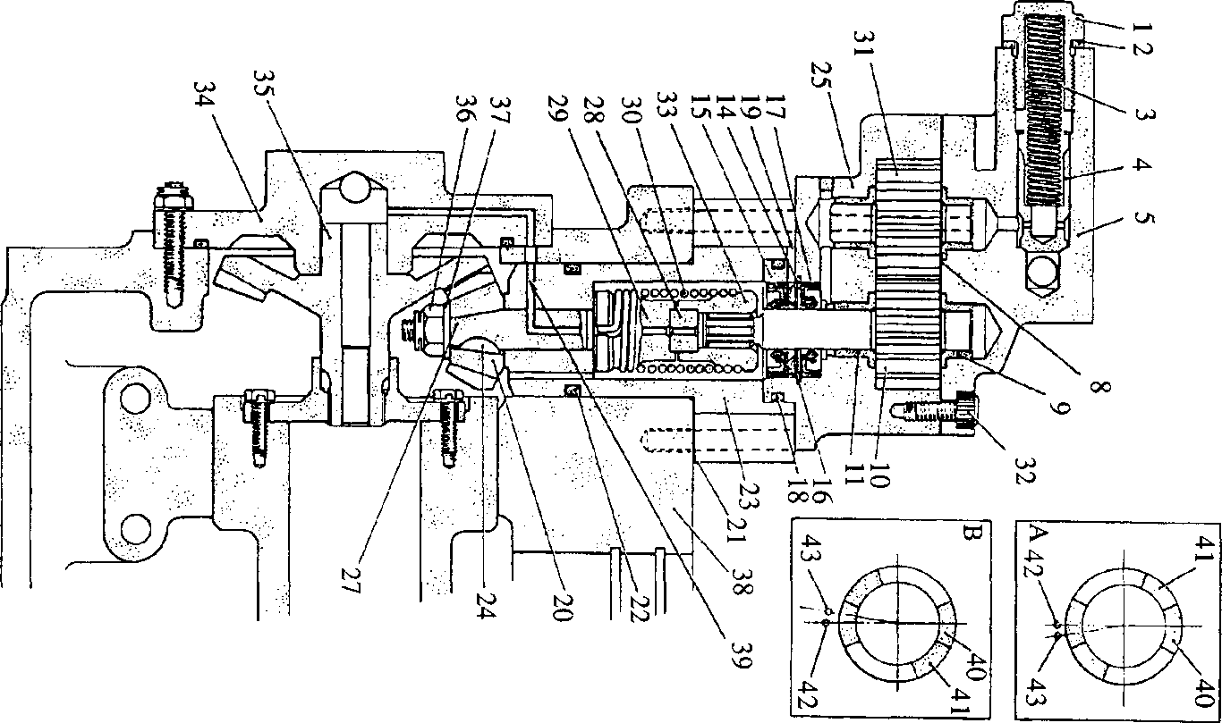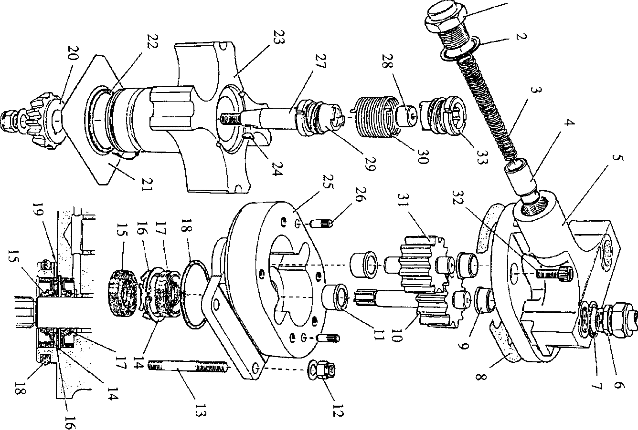

**SPD00468**

**Fig GC.l Fuel feed pump and drive**

SECTION GC

HAND OPERATED PRIMING PUMP

CONTENTS

|  |  |
| --- | --- |
|  | Chapter |
| Description | 1 |
| Servicing | 2 |

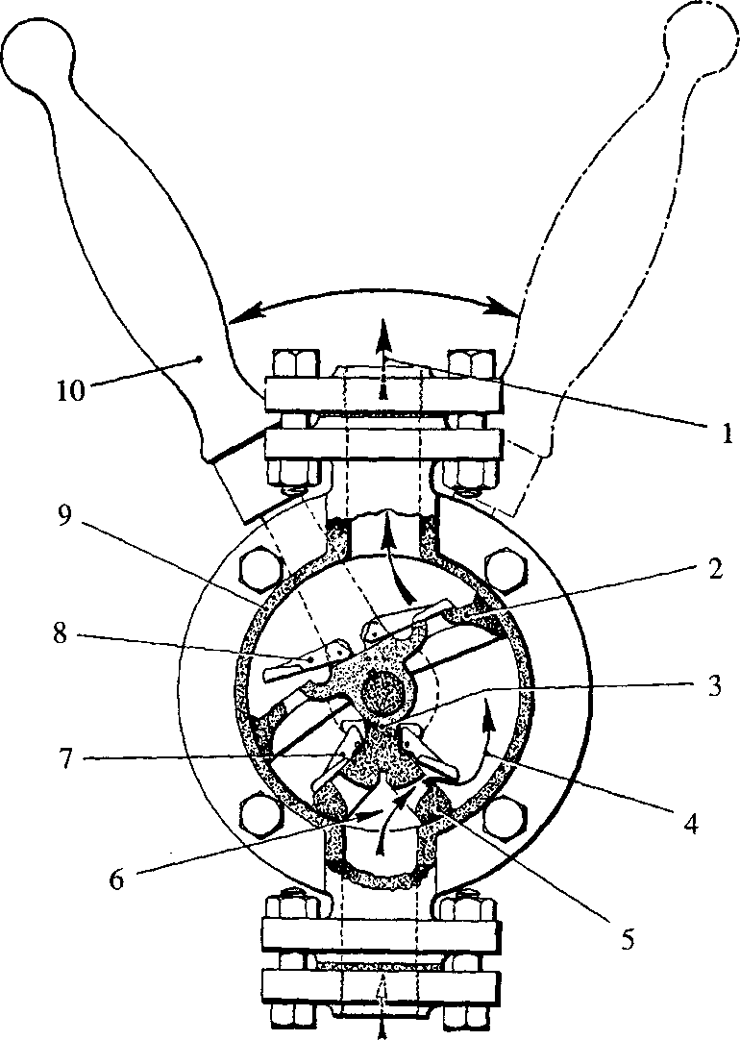

1.1

1.2

1.3

**CHAPTER 1**

**DESCRIPTION**

**Key to Numbers.**

1.

2.

3.

4.

5.

Delivery outlet 6.

Wing piston 7.

Packing strip 8.

Intermediate suction chamber 9. Fixed carrier plate 10.

Suction inlet Flap valve Flap valve Pump body Operating handle

**SPD00472**

**Fig GC.l Hand operated priming pump.**

The fuel oil priming pump, which is of the double-acting, semi-rotary, manually operated type is incorporated in the fuel system to enable it to be primed and all air expelled before attempting to start the engine. This eliminates the need to motor the engine to fill the fuel system.

The pump consists of an operating spindle carried in unbushed bearings and fitted with wing piston (2) which is a rubbing fit in body (9). The suction intake to the pump is divided by fixed carrier plate (5) which is sealed to the wing piston by packing (3). Gravity operated flap valves (7) and (8) fitted to the carrier plate and wing piston control the flow of fuel oil.

The spindle is sealed where it passes through the front cover by an 'O' ring type seal fitted in the front cover, whilst operating handle (10) is secured to the spindle by a locknut.

1. The rocking movement of the handle first draws fuel through flap valve (7) into intermediate suction chamber (4), the fuel then being transferred through flap valves (8) in the wing piston to the delivery chamber on the return movement of the handle. On the next movement of the handle, the fuel in the delivery chamber is forced through delivery outlet (1) by the fuel passing through the wing piston from the suction chamber.

CHAPTER 2

TO SERVICE.

To Dismantle

1. Drain the fuel system, ( Section GB).
2. Unscrew locknut and remove operating handle (10).
3. Release securing bolts and remove front cover.
4. Withdraw fixed carrier plate(s) and wing piston complete with spindle.

Inspection

1. Examine the rubbing faces on the wing piston and body for roughness.
2. Check that the flap valve on the wing piston and fixed carrier plate(s) seat correctly and squarely and move freely. Ensure the seatings are free from dirt.
3. Examine the body and front cover sealing faces for burrs and indentations which may prevent a satisfactory seal. This is a metal to metal joint.

Assembly

NOTE All joints and 'O' rings must be fitted dry.

1. Insert the operating spindle complete with wing piston and flap valves into the body bore.
2. Fit a new packing strip to the fixed carrier plate(s) and fit to body. Check that the carrier plate(s) is correctly engaged on its locating dowel and is fully bedded home into the body.
3. Fit a new 'O' ring seal to the spindle bore in the front cover, fit cover and tighten securing bolts.
4. Fit operating handle and securing nut.

NOTE The pump must be mounted in the vertical position. The lettering on the pump will indicate how it should be mounted.